Hi S. Hold!

Hope you are doing well. I had hoped to talk to you in person after the new product presentation last Friday. Nonetheless, this is a summary of the new Life Alert product design and the deliverables presented the stakeholder meeting last Friday.

I. ANALYSIS

Phase One of the new Life Alert product design details our analysis of the emergency medical response industry, user research, usability, and design ideas. The question our design must answer is “How can Life Alert best help seniors stay safe and maintain their independency?”

**Market Research**: These numbers are significant: 4.5% of seniors report owning a personal emergency button and 1.8% of seniors report owning a personal emergency button AND wearing it most of the time.

**Comparative Analysis**: Today’s wearable technology could inspire innovation and a new generation of medical alert systems.

**User Research**: While users expressed an interest in functionality that doesn’t currently exist in Life Alert, they also understand and believe in the value of medical alert systems. So, Life Alert currently has an opportunity to provide care at times when seniors want to stay healthy.

**Usability**: The design should be more discrete, monitor many types of health vitals, and increase safety functionality.

**Design Ideas**: The surveys revealed that seniors and caregivers wanted information about their health outside of an emergency. Caregivers wanted to also get notifications of alerts for emergencies and non-emergencies.

II. FINDINGS & RESULTS

Rather than a design in reaction to “catastrophic/emergency situations,” today’s new design seeks to emphasis “preventative care” to keep its users safe and healthy.

II. DELIVERABLES

Thus, the low-fidelity prototypes illustrate the key concepts and features to best serve the users of Life Alert.

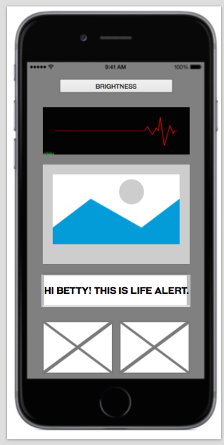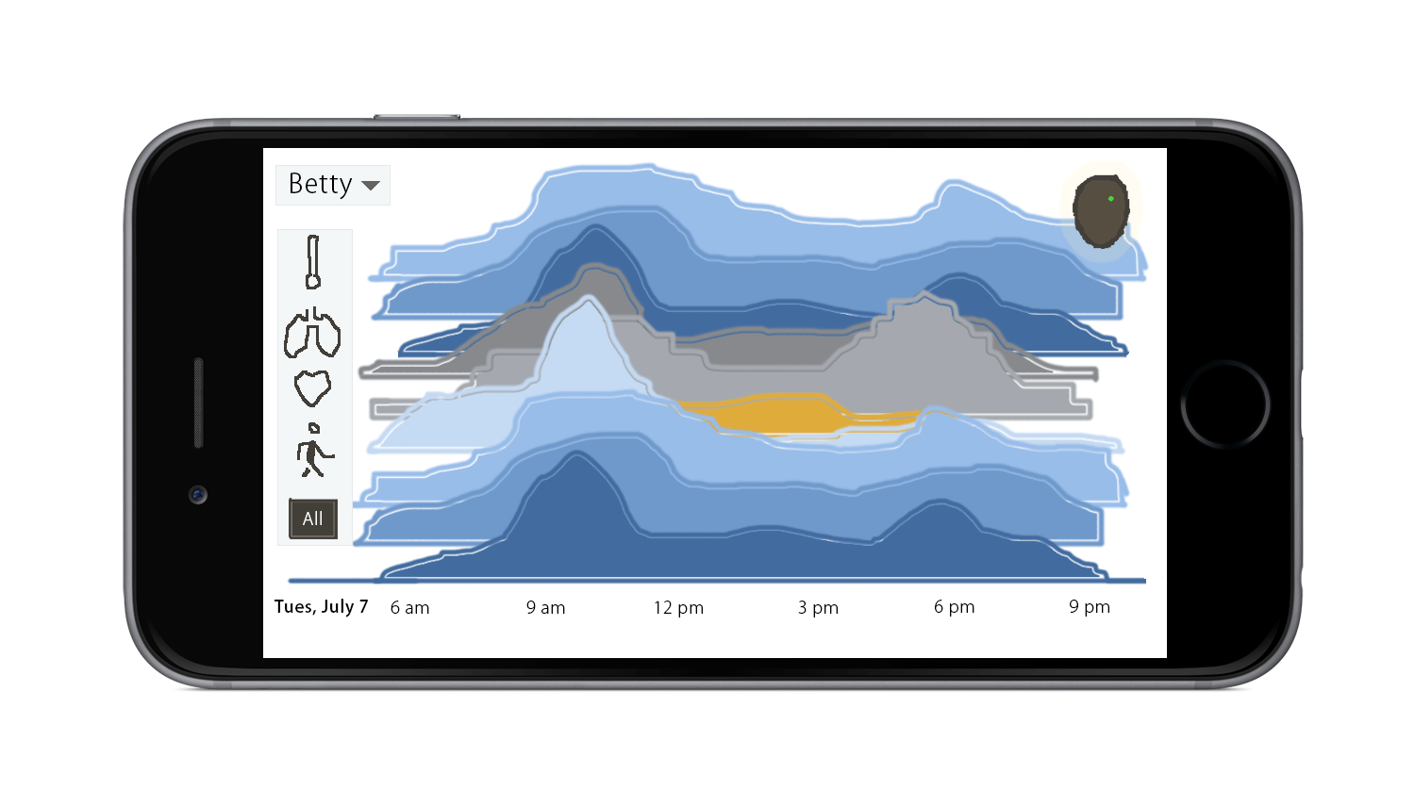

We have also made several recommendations as to the next step for developing the new Life Alert product design. Once approved, we can implement Phase Two within five (5) days of the signing-off.

If you have any questions, feedback, or suggestions, I would be happy to meet with you at your convenience. You can always reach me via mobile at 415-812-6282 or via email to [fanya.uxd@gmail.com](mailto:fanya.uxd@gmail.com). We look forward to working with you.

Best,

Fanya Young